**­2. (a) Setup a Jenkins Job with Apache Maven**

1. Pre-Requisites:
   1. Maven project should be available in GitHub.
2. Now, install Maven Integration plugin from the **Manage Jenkins->Manage Plugins option**.

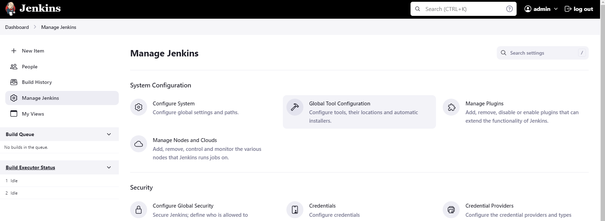

1. Now, configure Maven, Git and JDK in Jenkins by going to **Manage Jenkins->Global Tool Configuration**.
2. Add the respective paths to different env variables and save.

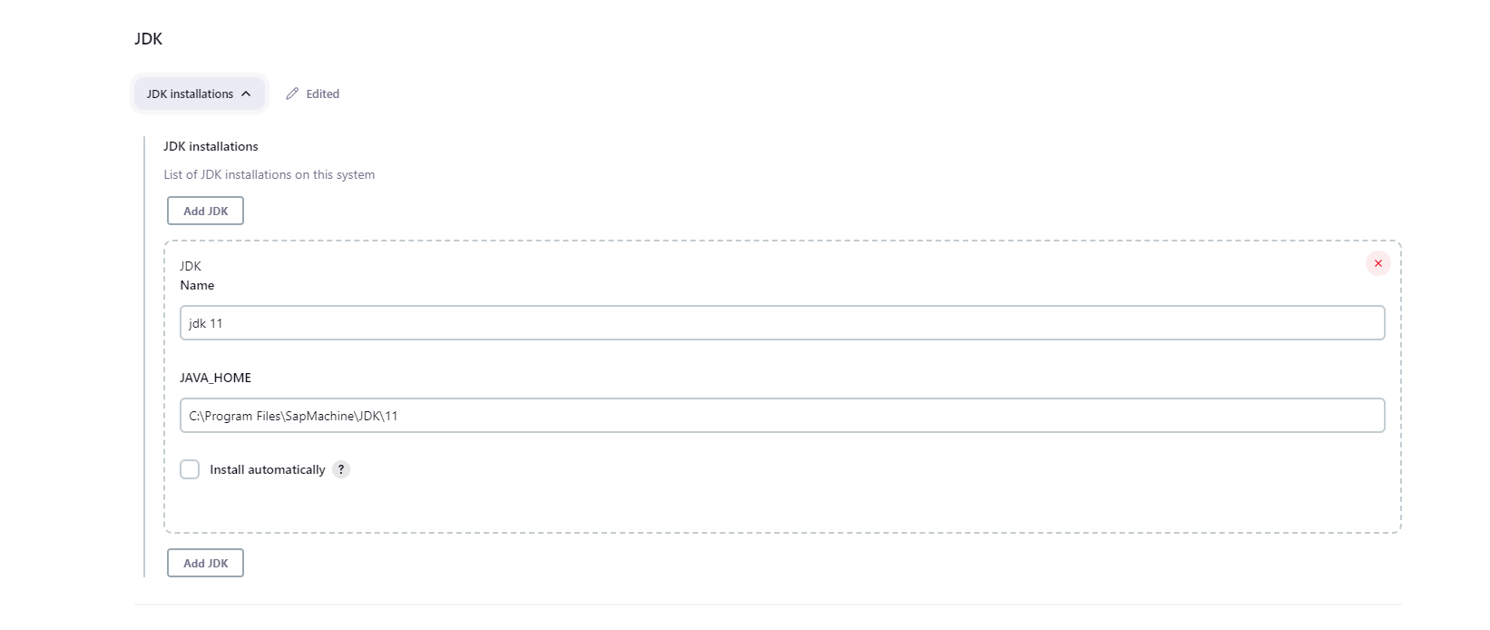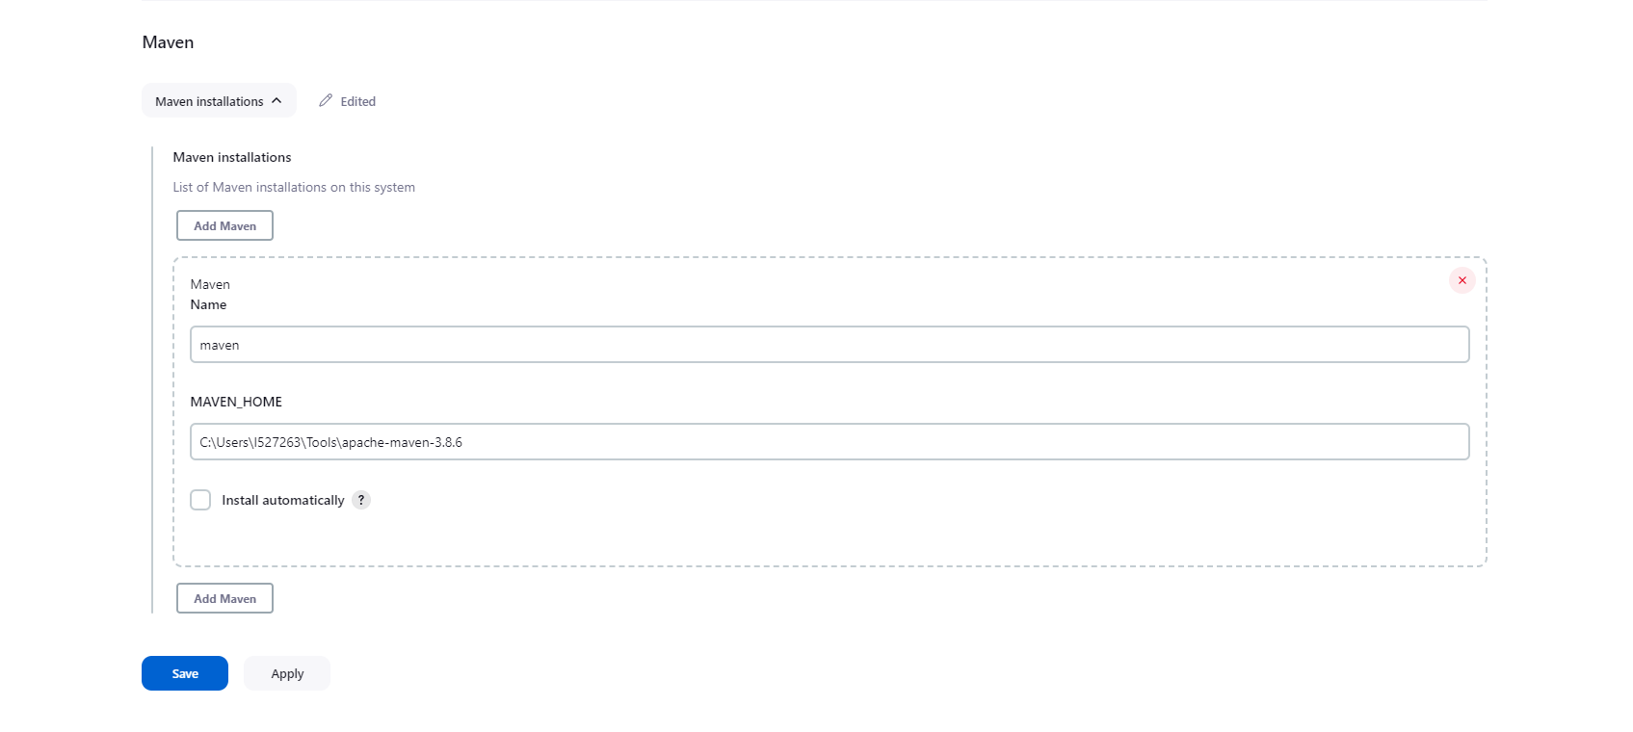

1. Now, click on New Item from the Dashboard and select Freestyle Project from the option, give a name to your project as well.

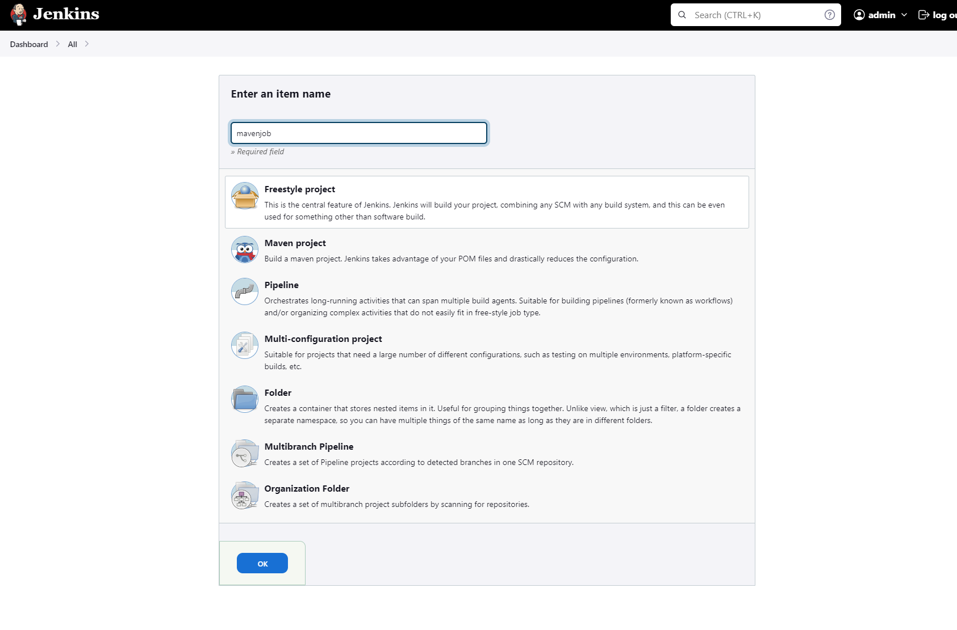

1. In the Configure Project Page, go-to Source Code Management and give your credentials and git repository link, if the repository is public, no need for any credentials. Click Save.

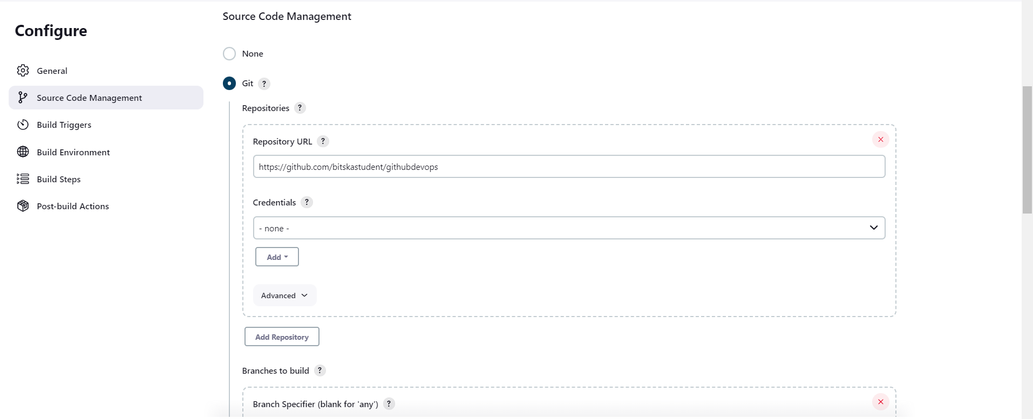

1. From the Dashboard, click on the created job and select Build Now, the build will start.

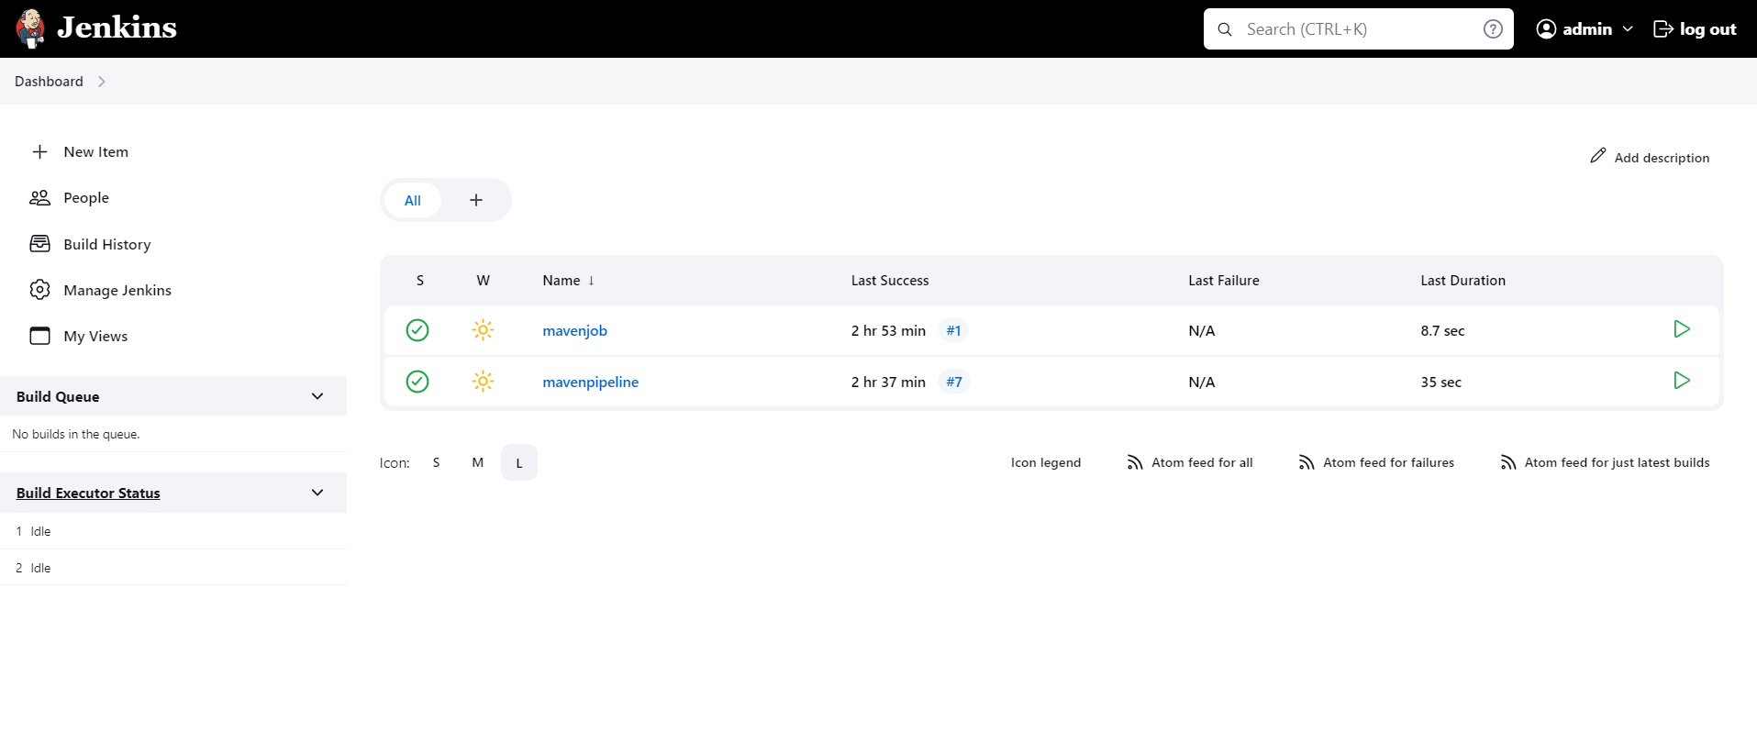

1. Here are the outputs for the build ran as a job.

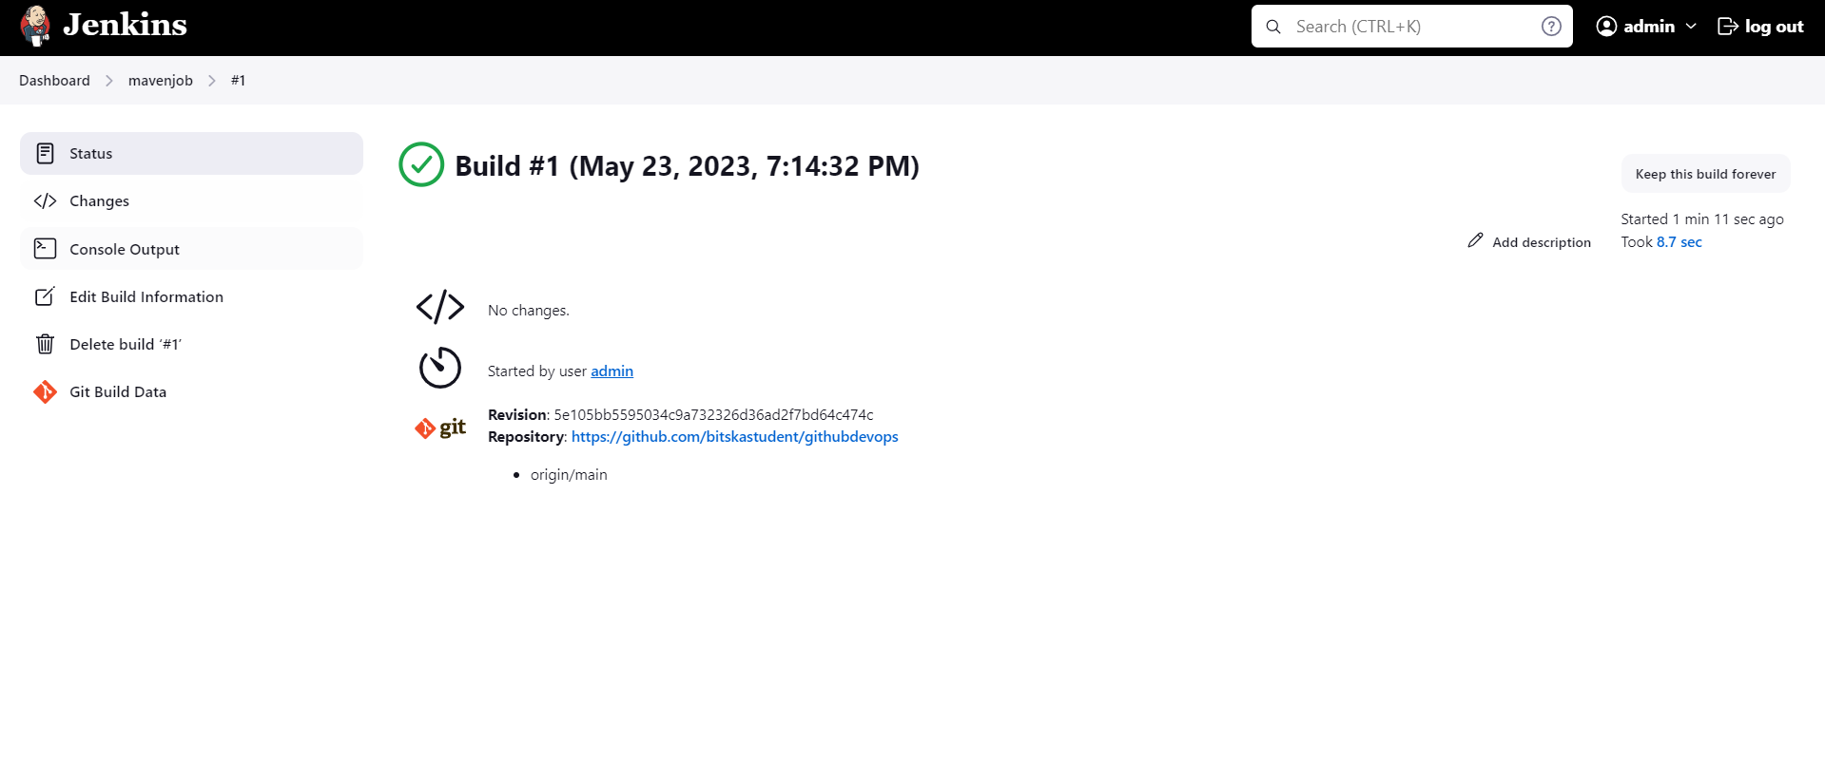

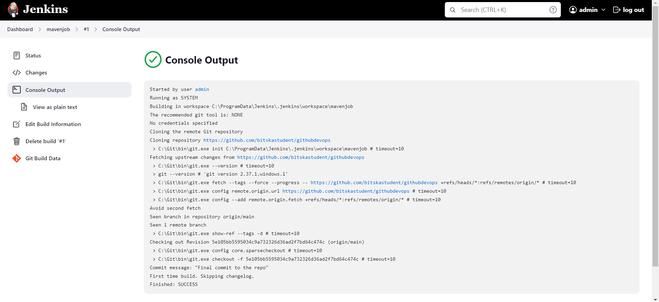

**2.b Setup a Jenkins build Pipeline with Build, Test, Package, Deploy.**

1. If you have setup Jenkins with recommended options, you won’t have to install any extra plugins, just click on New Item again and select Pipeline.

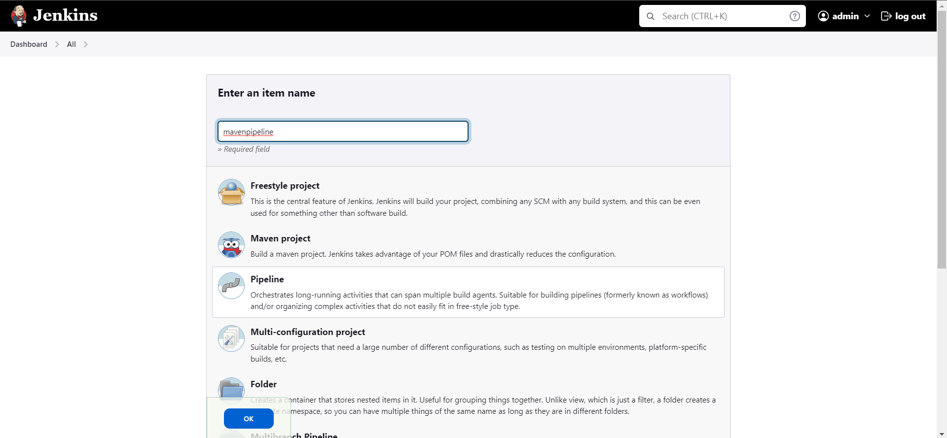

2. In your GitHub Repo, add the following Jenkinsfile in the root directory.

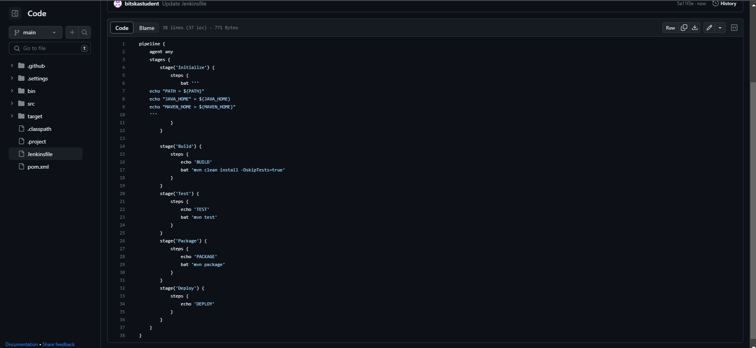

3. Now, in the configure page, go-to the Pipeline section and select ‘from SCM’ option and give the following details as mentioned. Save when done.

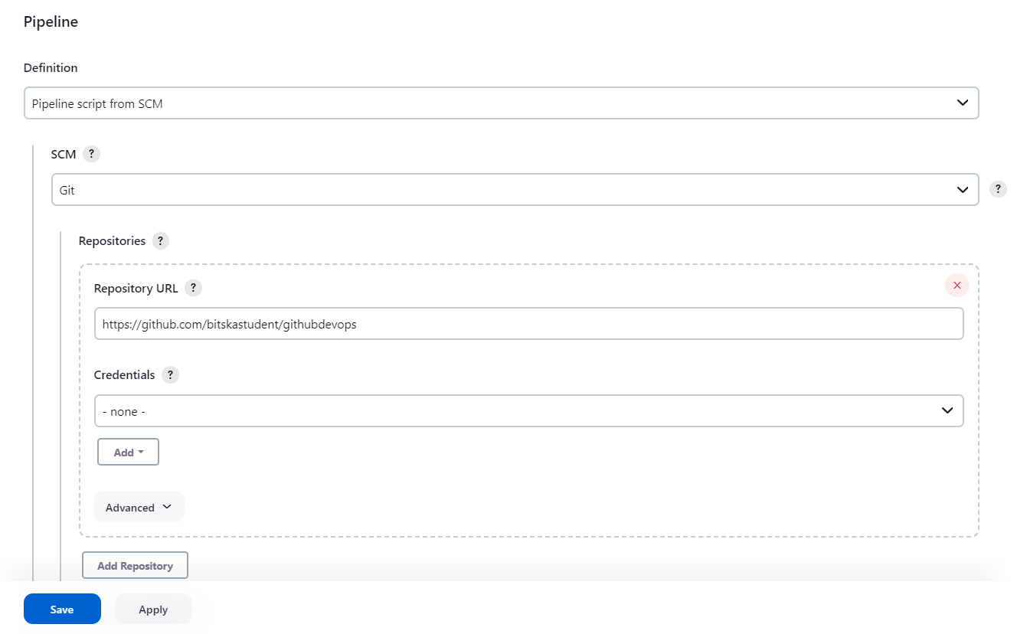

4. From the Pipeline page, click Build Now and all the mentioned stages in Jenkinsfile of your repo will run.

